POS SYSTEM – ARCHITECTURE DRIVERS

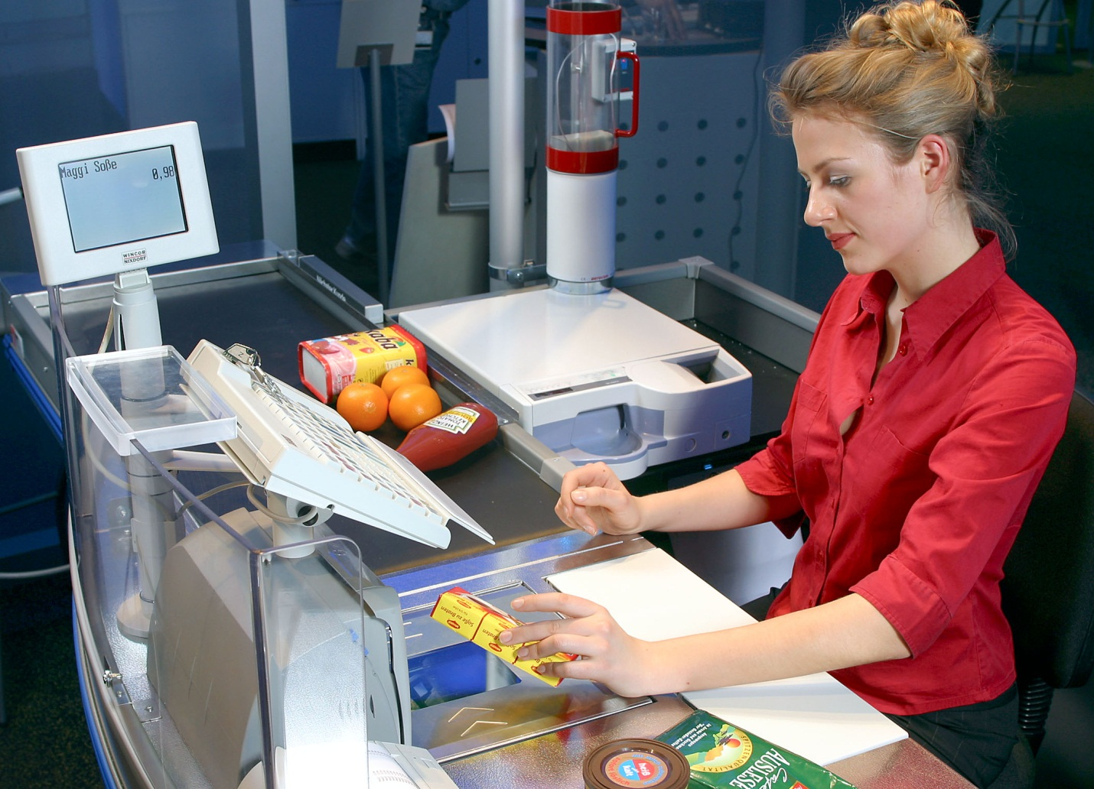

HIT Team

Consulting

Sales

Staffing

Support

# Information of document

|  |  |
| --- | --- |
| **Title** | **Architecture Driver Document** |
| **Author(s)** | All team |
| **Reviewer(s)** | All team |
| **Team name** | HIT Team |
| **Team members** | Thanh Giang, Hiep Ta, Phuc Nguyen, Giang Nguyen, Dat Tran, Huy Huynh |
| **Project mentors** | Ms. Huong Nguyen, Mr. Huyen Pham |
| **Editor** |  |
| **Type of report** | Architecture Driver Document |
| **Software used** | MS Word |

# Document Reviewer Information

|  |  |  |
| --- | --- | --- |
| Reviewer Name | Review Attendance (R/S) | Comments |
|  |  |  |
|  |  |  |
|  |  |  |

# Document Approver Information

|  |  |  |
| --- | --- | --- |
| Approver Name | Approver Function | Comments |
|  |  |  |
|  |  |  |
|  |  |  |

# Document Revision History

|  |  |  |  |  |
| --- | --- | --- | --- | --- |
| Date | Revision | Status | Change Summary | Revised by |
| 6/3/2012 | 1.0 |  | Consume Team member’s tasks | Thanh Giang |
| 15/4/202 | 1.1 |  | Update Quality Attributes | Giang Nguyen |
| 18/4/2012 | 1.2 |  | Usecase | Thanh Giang |
| 24/05/2012 |  | start | Use case Description | Hiep Ta |

1. **INTRODUCTION** 
   1. **Purpose of this document**

This section of the Architectural Driver gives an overview of the business context and the architectural drivers with their impact on the project. It also contains the project deliverables, the summary of the schedule the SPMP. We also show the development strategy that we choose to show how this may affect the design of a system.

* 1. **Project Summary**

* 1. **Document's intended audience**

|  |  |
| --- | --- |
| Intended Audience | Reading Suggestions |
| Project Manager | Section 2 – The architectural Drivers: List functions showed by use-case diagrams and constrains to make the Project Manager has an overview. So he can have the estimates for the project.  Section 3 – The development Strategy |
| Software Architecture and Designer | Section 2 – The architectural Drivers: This section describes Use-case diagram and Use-case descriptions. It makes easily to design and develop the proposed system. |
| Tester | The Overview section and Use-case: they will help to make the test plan and write the acceptance test |

1. **The architectural drivers**
   1. **High-level Functional Requirements**

|  |  |  |  |
| --- | --- | --- | --- |
| Use Case ID | Use Case Name | Important Level | Difficulty Level |
| System Management | | | |
| UC_SM01 | Add New User | High | High |
| UC_SM02 | Search/ View User List | Medium | Low |
| UC_SM03 | View User Detail Information | Normal | Low |
| UC_SM04 | Update User Information, Assign Authorize | High | High |
| Product Management | | | |
| UC_PM01 | Add New Product | High | Medium |
| UC_PM02 | Search/ View Product List | Medium | Low |
| UC_PM03 | View Product Detail Information | Medium | Low |
| UC_PM05 | Update Product Information | Medium | Medium |
| Record Management | | | |
| UC_RM01 | Add New Record | High | High |
| UC_RM02 | Search/ View Record List | Medium | Low |
| UC_RM03 | View Record Detail Information | Medium | Low |
| UC_RM04 | Print Record | Medium | Medium |
| Retail Stores Management | | | |
| UC_RSM01 | Add New Store | High | Medium |
| UC_RSM02 | Search/ View Store List | Medium | Low |
| UC_RSM03 | View Store Detail Information | Medium | Low |
| UC_RSM04 | Update Store Information | Medium | Medium |
| Category Management | | | |
| UC_CM01 | Add New Category | High | Medium |
| UC_CM02 | Search/ View Category List | Medium | Low |
| UC_CM03 | View Category Detail Information | Medium | Low |
| UC_CM04 | Update Category Information | Medium | Medium |
| Customer Management | | | |
| UC_C01 | Add New Customer | High | Medium |
| UC_C02 | Search/ View Customer List | Medium | Low |
| UC_C03 | View Customer Detail Information | Medium | Low |
| UC_C04 | Update Customer Information | Medium | Medium |
| UC_C05 | View Customer Point Log | High | Medium |
| Statistic | | | |
| UC_S01 | Analysis Statistic | Low | High |
| User Computer Management | | | |
| UC_P01 | Add New User Computer | High | Medium |
| UC_P02 | Search/ View User Computer List | Medium | Low |
| UC_P03 | View User Computer Detail Information | Medium | Low |
| UC_P04 | Update User Computer Information | Medium | Medium |
| View Point | | | |
| UC_VP | View Point | High | High |

* + 1. **Actor table**

|  |  |
| --- | --- |
| Actor | Description |
| Administrator | Responsible for manage user of the system such as: Create new, assign authorize. Manage User Computer by setting static IP, avoid unauthorized users logging in from elsewhere. |
| Manager | Responsible for manage information of retail stores, and they can statistic sales by many criterion |
| Staff | Responsible for manage information of products, categories, customer |
| Cashier | Responsible for check bills (bills) |
| User | Includes Manager, cashier and admin: they can use basic function like: log in, logout, change password |

* + 1. **Use-case Diagrams and Use-case Descriptions**

***Please Reference “POSSystem_Usecase”***

* 1. **Constrains:**
     1. **Business Constrains:**

|  |  |  |
| --- | --- | --- |
| Consideration | ID | Business Constraints. |
| Schedule limitations. | **BC01** | 1 Project Management – 120h (4h/day) |
| 2 Programmer – 120h (4h/day) |
| 1 Architect – 90h (3h/day) |
| 2 Tester – 90h (3h/day) |
| 1 Requirement -180h (6h/day) |
| Mandatory regulatory restrictions and demands. | **BC02** | Customers who have become point service members are issued point cards. Points can be used in all stores.  The member the either pays with cash, points, or a combination of the two |
| Market restrictions and demands. | **BC03** | The actual retail price must be set in advance. |
| Organizational restrictions and demands. | **BC04** | One team with 6 members |

* + 1. **Technical Constrains:**

|  |  |  |
| --- | --- | --- |
| Consideration. | ID | Technical Constraints |
| Peripheral or network hardware. | TC01 | Database server |
| Commercial hardware or software products. | TC02 | Bar code readers  Keyboard  Computer |
| Tools and methods. | TC03 | SQL Database Server |
| Protocols, interfaces, standards. | TC04 | TCP/IP protocol |

* 1. **Quality Attributes**
* **Quality Attribute Ranking Table**

|  |  |  |  |
| --- | --- | --- | --- |
| Quality Attribute | Important (base on customer) | Difficult level (to implement) | Priority |
| Performance | **High** | **High** | **High** |
| Security | **High** | **High** | **High** |
| Availability | **Medium** | **Medium** | **Medium** |
| Usability | **Medium** | **Low** | **Low** |

* **List of quality attributes**

|  |  |  |  |  |
| --- | --- | --- | --- | --- |
| Quality | Quality ID | Concern | Use case | Attribute |
| **Performance** | QP01 | Response time | UC_SM02 - Search/ View User List  UC_SM03 - View User Log  UC_SM04 - View User Detail Information  UC_PM02 - Search/ View Product List  UC_PM03 - View Product Detail Information  UC_PM04 - Choose Category  UC_RM02 - Search/ View Bill List  UC_RM03 - View Bill Detail Information  UC_RM04 - Print Bill  UC_RSM02 - Search/ View Store List  UC_RSM03 - View Store Detail Information  UC_CM02 - Search/ View Category List  UC_CM03 - View Category Detail Information  UC_C02 - Search/ View Customer List  UC_C03 - View Customer Detail Information  UC_P03 – Search/ View computer Detail Information  UC_C04 - Update Customer Information  UC_C05 - View Customer Point Log  UC_CM01 - View Point | Indication of responsiveness of a system to execute any action within a given time interval. It can be measured in terms of latency or throughput. Latency is the time taken to respond to any event. Throughput is the number of events that take place within a given amount of time |
| QP02 | Delay time | UC_SM06 - Update User Information  UC_SM07 - Sync Information  UC_PM05 - Update Product Information  UC_RSM04 - Update Store Information  UC_CM04 - Update Category Information  UC_CM04 - Update Category Information  UC_T01 - Update Information  UC_P04 – Update computer Information | For interactive into systems requires more time to handling, these transactions are processed and with an average latency of two seconds. |
| **Availability** | QA01 | Easy to configure | UC_SM01 - Add New User  UC_PM01 - Add New Product  UC_RM01 - Add New Bill  UC_RSM01 - Add New Store  UC_CM01 - Add New Category  UC_C01 - Add New Customer  UC_P01 – Add new computer  UC_SM05 - Assign Authorize | Concerned with system failure and its associated consequences. A system failure occurs when the system no longer delivers a service consistent with its specification |
| **Security** | QS01 | Security customer’s information | UC_S01- Statistic Information  UC_Login | The capability of a system to prevent malicious or accidental actions outside of the designed usage, and to prevent disclosure or loss of information. A secure system aims to protect assets and prevent unauthorized modification of information |

* + 1. **Performance:**
* Scenario ID: QA_P01

Sales staff scanning products code while the system is operating normally, the system will display product’s information within 1 second

|  |  |
| --- | --- |
| **Portion of scenario** | **Possible values** |
| **Source** | Sales staff |
| **Stimulate** | Scanning products code |
| **Artifact** | System, information in the system |
| **Evironment** | System is operating normally |
| **Respone** | Display product’s information |
| **Respone measure** | within 1 second |

* Scenario ID: QA_P02

The manager performs the statistical reports while the system is operating normally, the system displays information reported within 5 seconds

|  |  |
| --- | --- |
| **Portion of scenario** | **Possible values** |
| **Source** | The manager |
| **Stimulate** | Performs the statistical reports |
| **Artifact** | System, information in the system |
| **Evironment** | System is operating normally |
| **Respone** | System displays information reported |
| **Respone measure** | Within 5 seconds |

* Scenario ID: QA_P03

The staff scans the customer's card while the system is operating normally, the system displays the customer information within 2 s

|  |  |
| --- | --- |
| **Portion of scenario** | **Possible values** |
| **Source** | The staff |
| **Stimulate** | Scans the customer's card |
| **Artifact** | System, information in the system |
| **Evironment** | System is operating normally |
| **Respone** | System displays the customer information |
| **Respone measure** | Within 2 s |

* Scenario ID: QA_P04

Sales staff sends confirmation of payment request while the system is operating normally, system confirm request, save billing information in the database and notify successful payment within 2 s

|  |  |
| --- | --- |
| **Portion of scenario** | **Possible values** |
| **Source** | Sales staff |
| **Stimulate** | Sends confirmation of payment request |
| **Artifact** | System, information in the system |
| **Evironment** | System is operating normally |
| **Respone** | System confirm request, save billing information in the database and notify successful payment |
| **Respone measure** | Within 2 s |

* + 1. **Availability:**
* Scenario ID: QA_A01

Computer in retail store send a request for bill payment to server in head office while the system is operating normally. The system will accept payment requests, stores the information in the database and respond to machines in retail store with no downtime

|  |  |
| --- | --- |
| **Portion of scenario** | **Possible values** |
| **Source** | Computer in retail store |
| **Stimulate** | request for bill payment |
| **Artifact** | System, information in the system |
| **Evironment** | System operating normally |
| **Respone** | The system will accept payment requests, stores the information in the database and respond to machines in retail store |
| **Respone measure** | No downtime |

* + 1. **Security**
* Scenario ID: QA_S01

Sales staff login into the system from an external computer while the system is operating normally. The system will not allow logins and sends out a message to the user that they can’t log in from external computer systems

|  |  |
| --- | --- |
| **Portion of scenario** | **Possible values** |
| **Source** | Sales staff |
| **Stimulate** | Login into the system from an external computer |
| **Artifact** | System, information in the system |
| **Evironment** | System is operating normally |
| **Respone** | The system will not allow logins and sends out a message to the user that they can’t log in from external computer systems |
| **Respone measure** | Within 2 s show “Login failed” message |

* Scenario ID: QA_S02

The manager request to view a statistical report from any computer with an internet connection while the system is operating normally. The system displays the information reported within 5 seconds

|  |  |
| --- | --- |
| **Portion of scenario** | **Possible values** |
| **Source** | The manager |
| **Stimulate** | Request to view a statistical report from any computer with an internet connection |
| **Artifact** | System, information in the system |
| **Evironment** | System is operating normally |
| **Respone** | The system displays the information reported |
| **Respone measure** | Within 5 seconds |

## -- The End --